**Practical 00**

1. **Add a break point.**

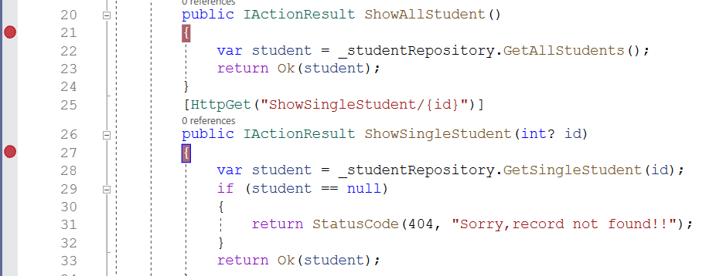

1. **Quick watch.**

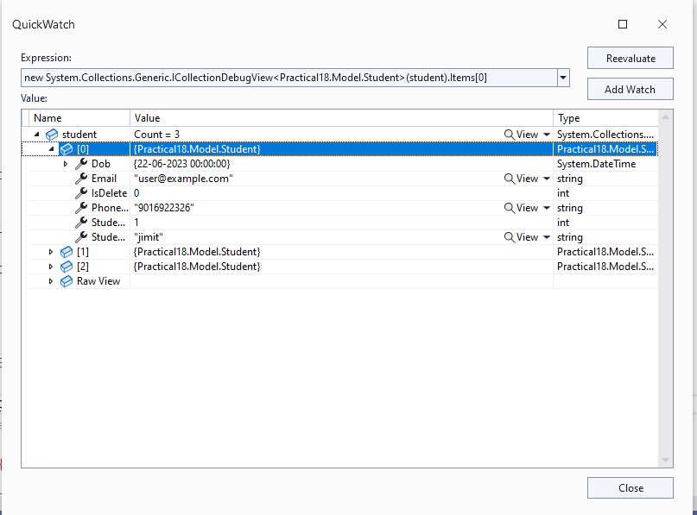

1. **Conditional Breakpoints**

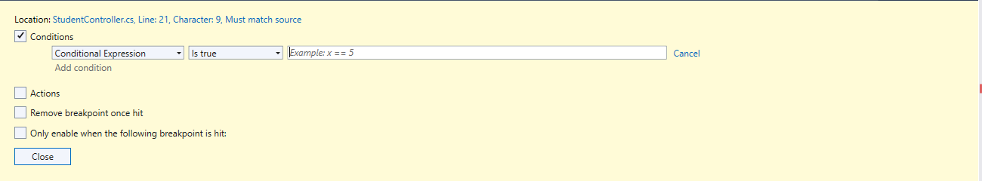

1. **Exception Viewer**

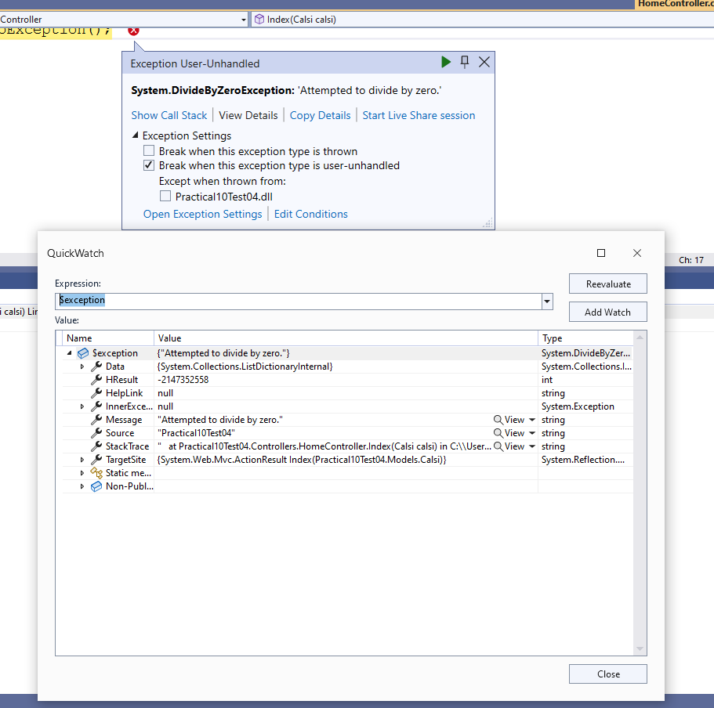

1. **IEnumerable Visualizer.**

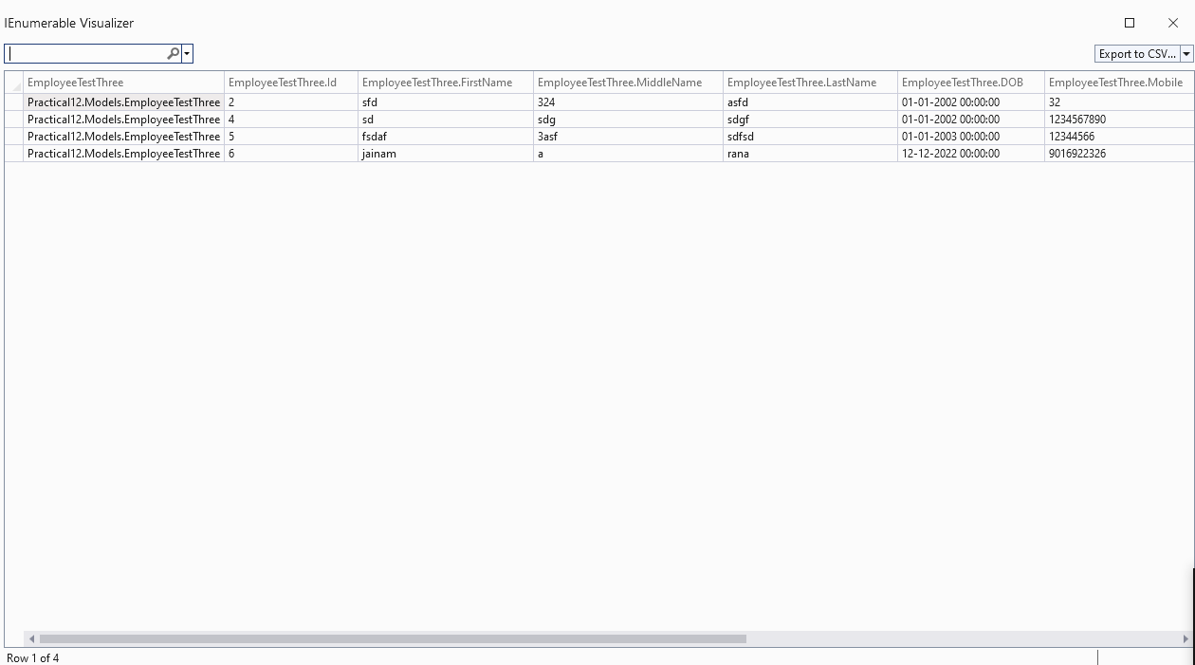

1. **Intermediate Window**

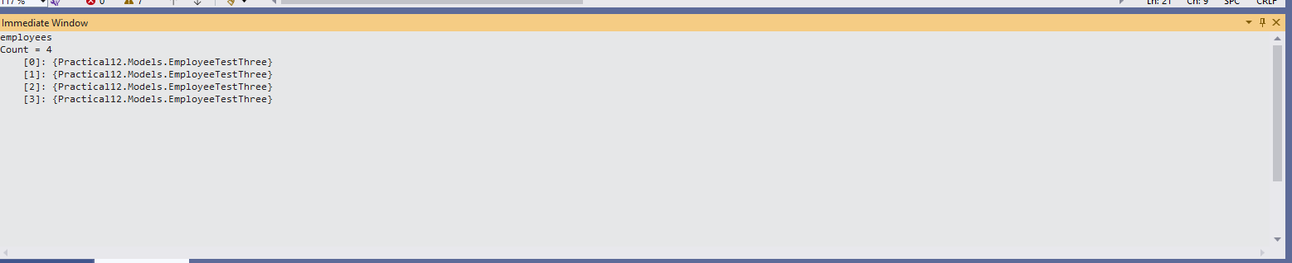

1. **Call Stack**

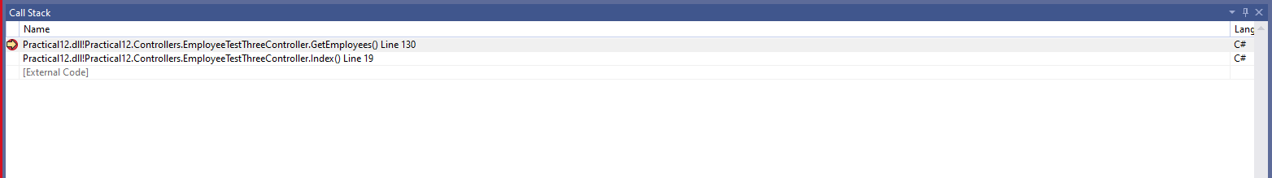

1. **Hot Reload**

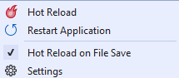

1. **Git Clone**

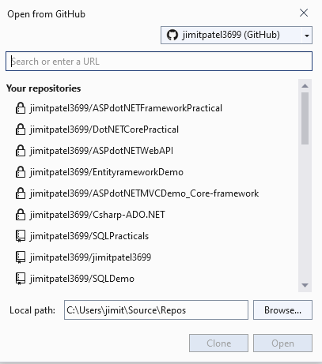

1. **Git Explorer**

